**DDR4 vs. DDR5 RAM for Intel 12th-Gen Core**

We'll look at memory scaling performance with Intel Alder Lake CPUs, notably the Core i9-12900K, in this article, while the results should apply to the complete 12th-gen Core range, especially when CPU restricted.

In a previous benchmark feature, we compared DDR4-3600 vs. DDR5-6000 memory in 41 games and discovered that the newer and more expensive DDR5 memory was just 4% faster on average, however it was up to 20% faster in a few titles. Because the DDR4 and DDR5 memory utilised in that testing were both quite expensive, we'd like to examine a variety of memory kits from Corsair, all of which are available at different price points.

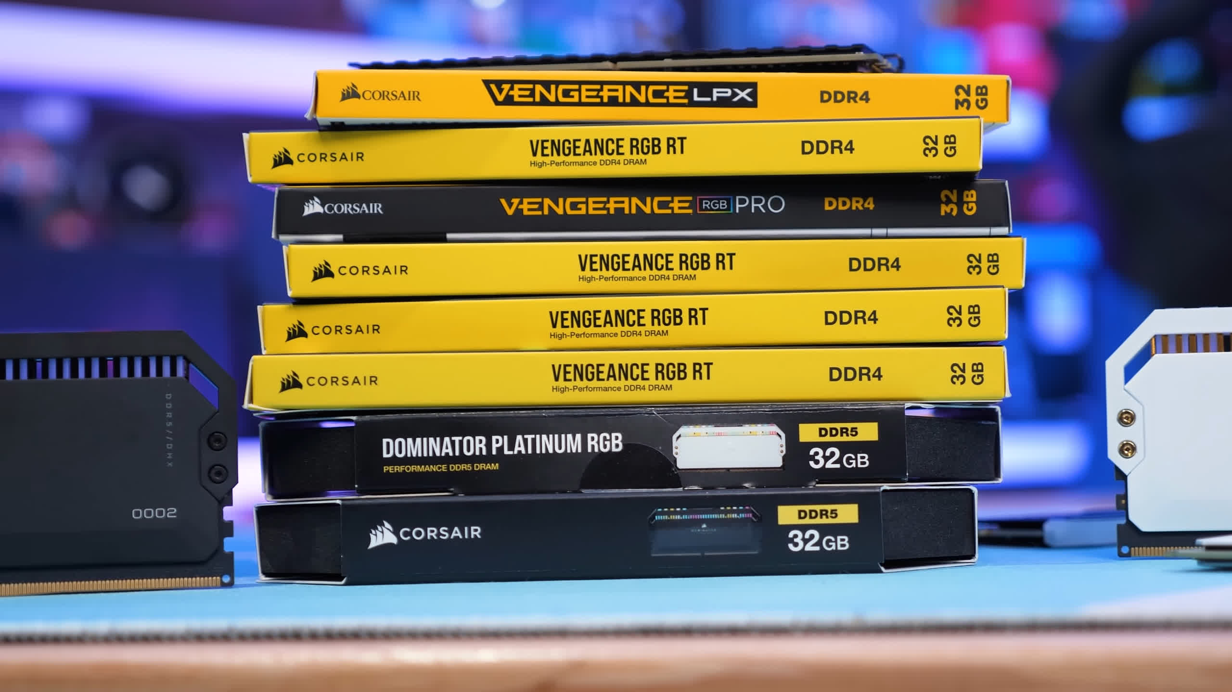

The goal of this test isn't to take a few high-end kits and manually alter timings and frequencies like we have in the past. Instead, we'd like to put real-world memory kits to the test to evaluate how they perform and compare. We contacted Corsair with a large shopping list of kits we needed to test, and they were more than willing to assist us.

We have nine 32GB memory packages in total, ranging from 2400 to 6200 MHz, from the Vengeance LPX, Vengeance RGB RT, Vengeance RGB Pro, and Dominator Platinum RGB series. For each kit, we used the default timings and labelled the graphs with the primary timings. We simply installed XMP on the MSI Z690 Tomahawk DDR4 and DDR5 motherboards and manually modified the gear mode to display gear 1 and gear 2 performance in two instances.

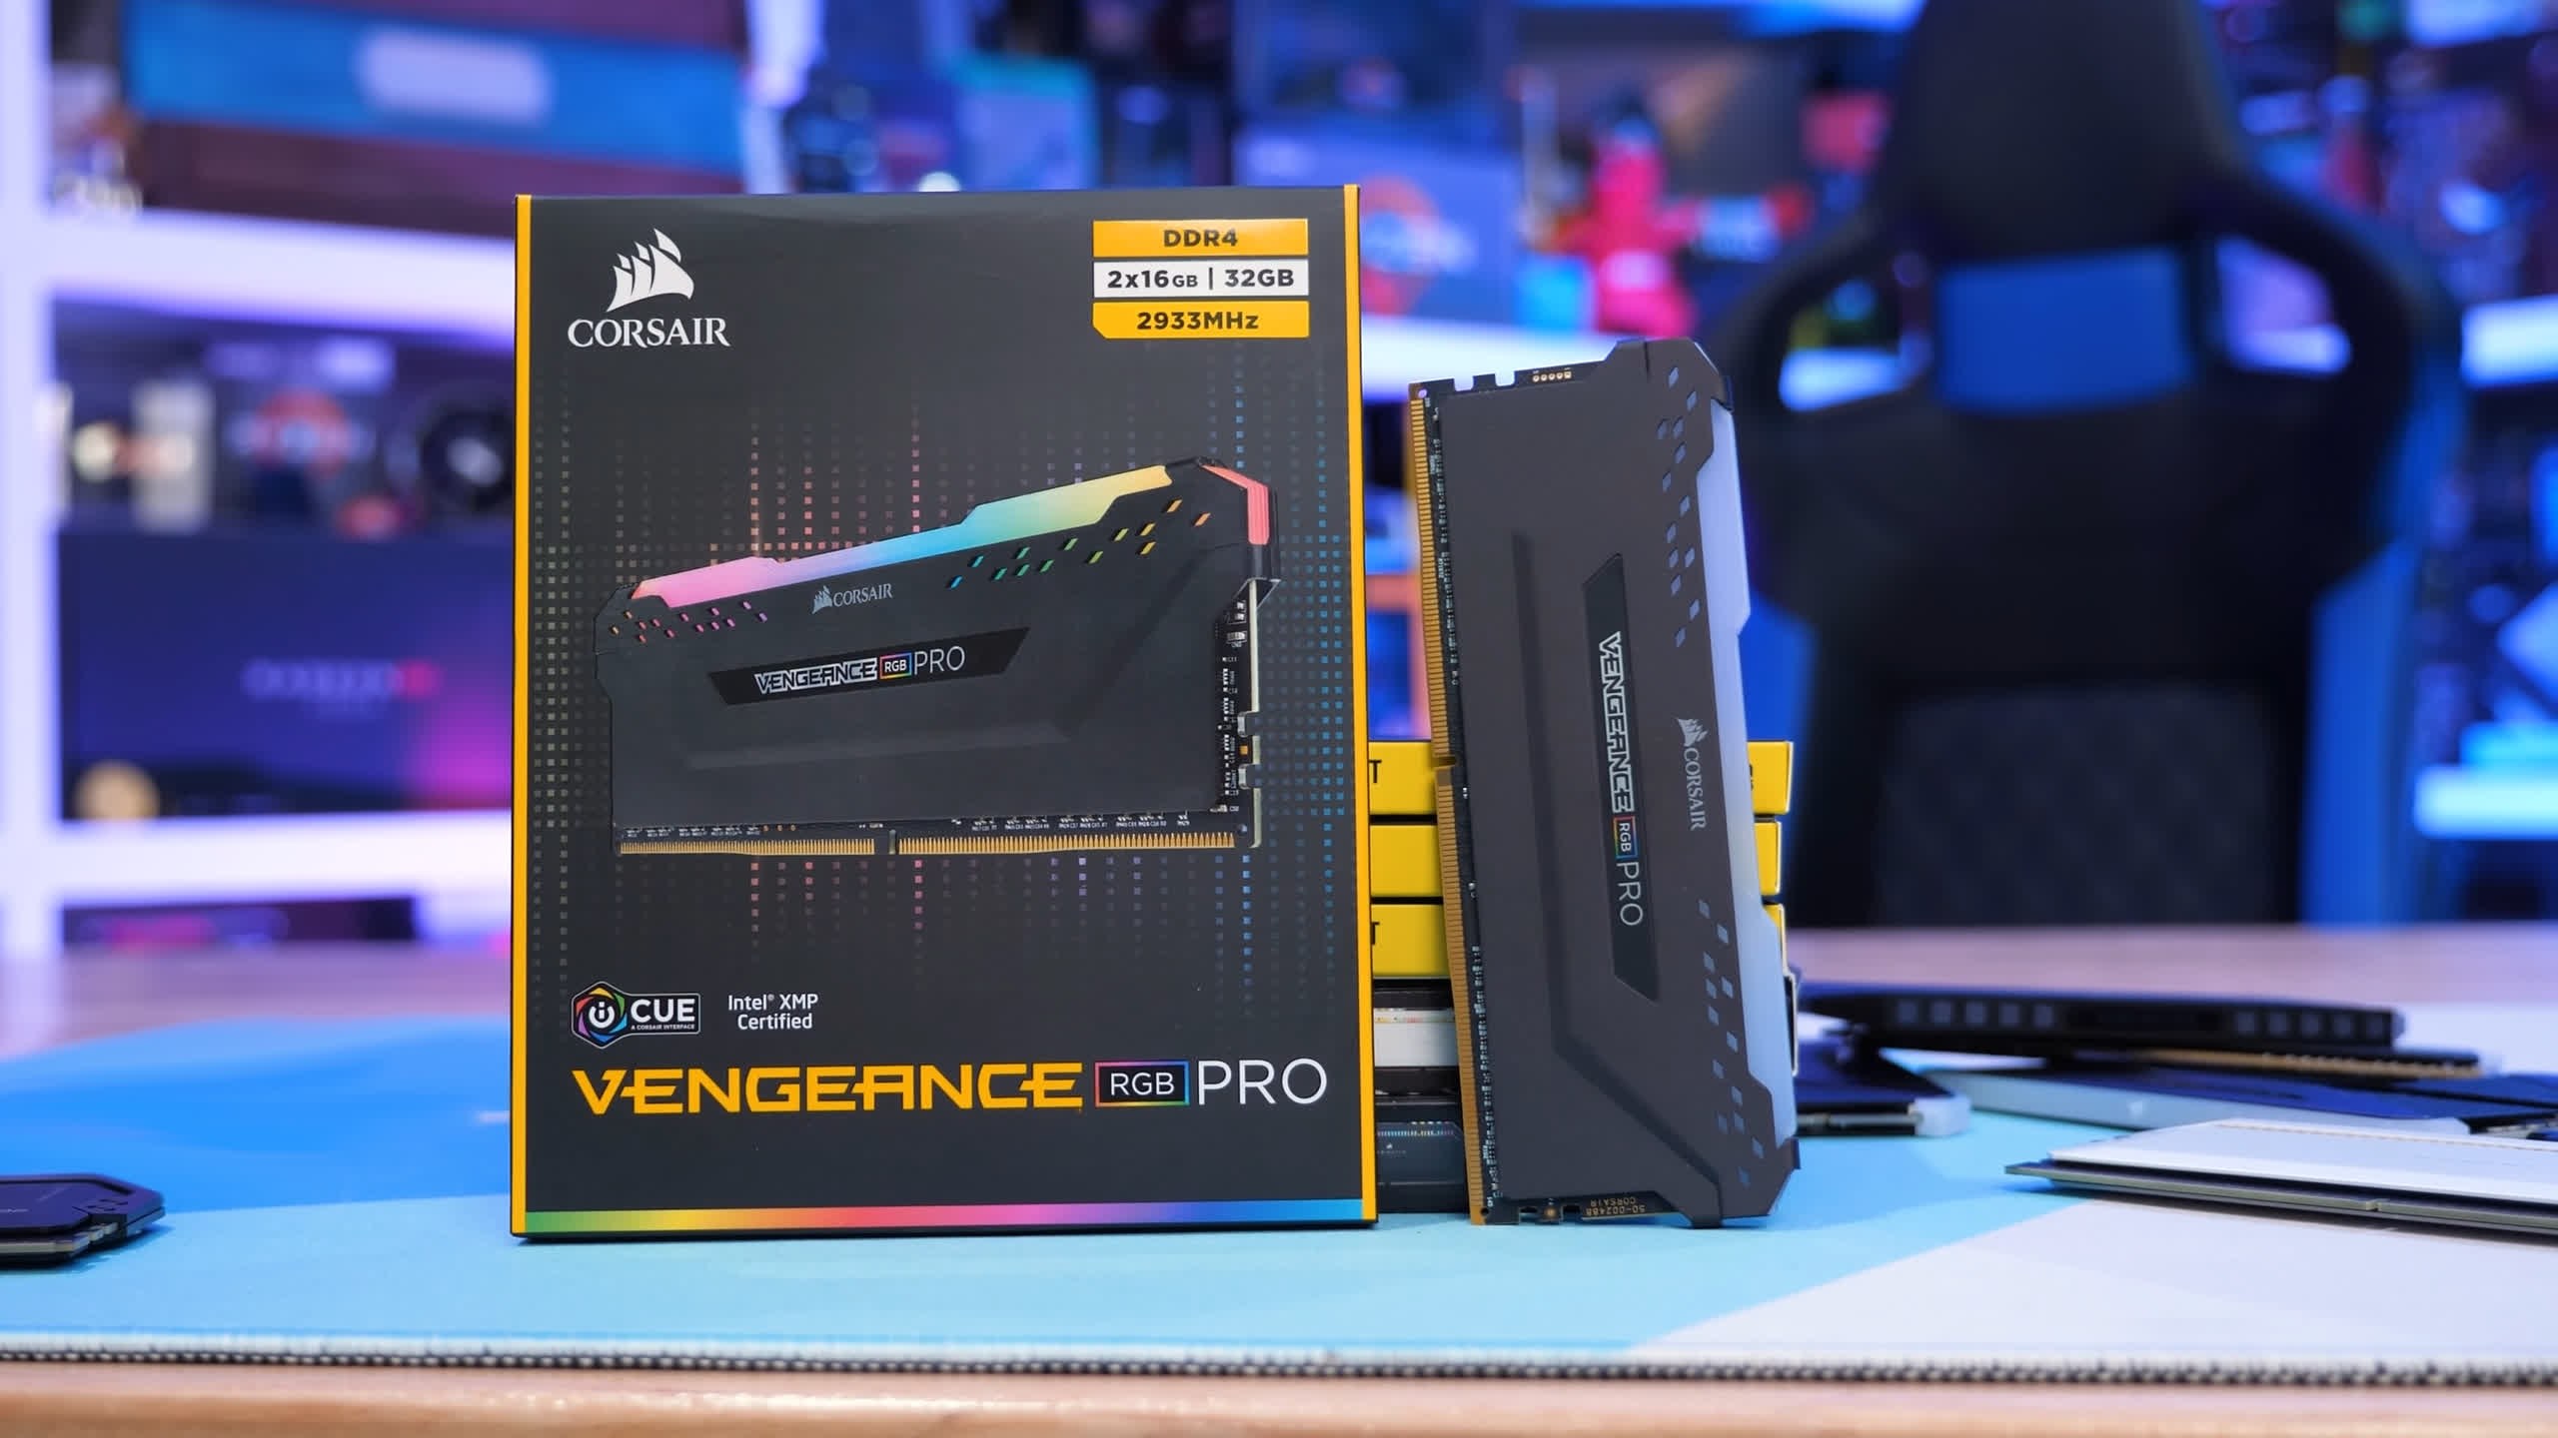

We used a Radeon RX 6900 XT to complete our test bench, and now it's time to look at the results…

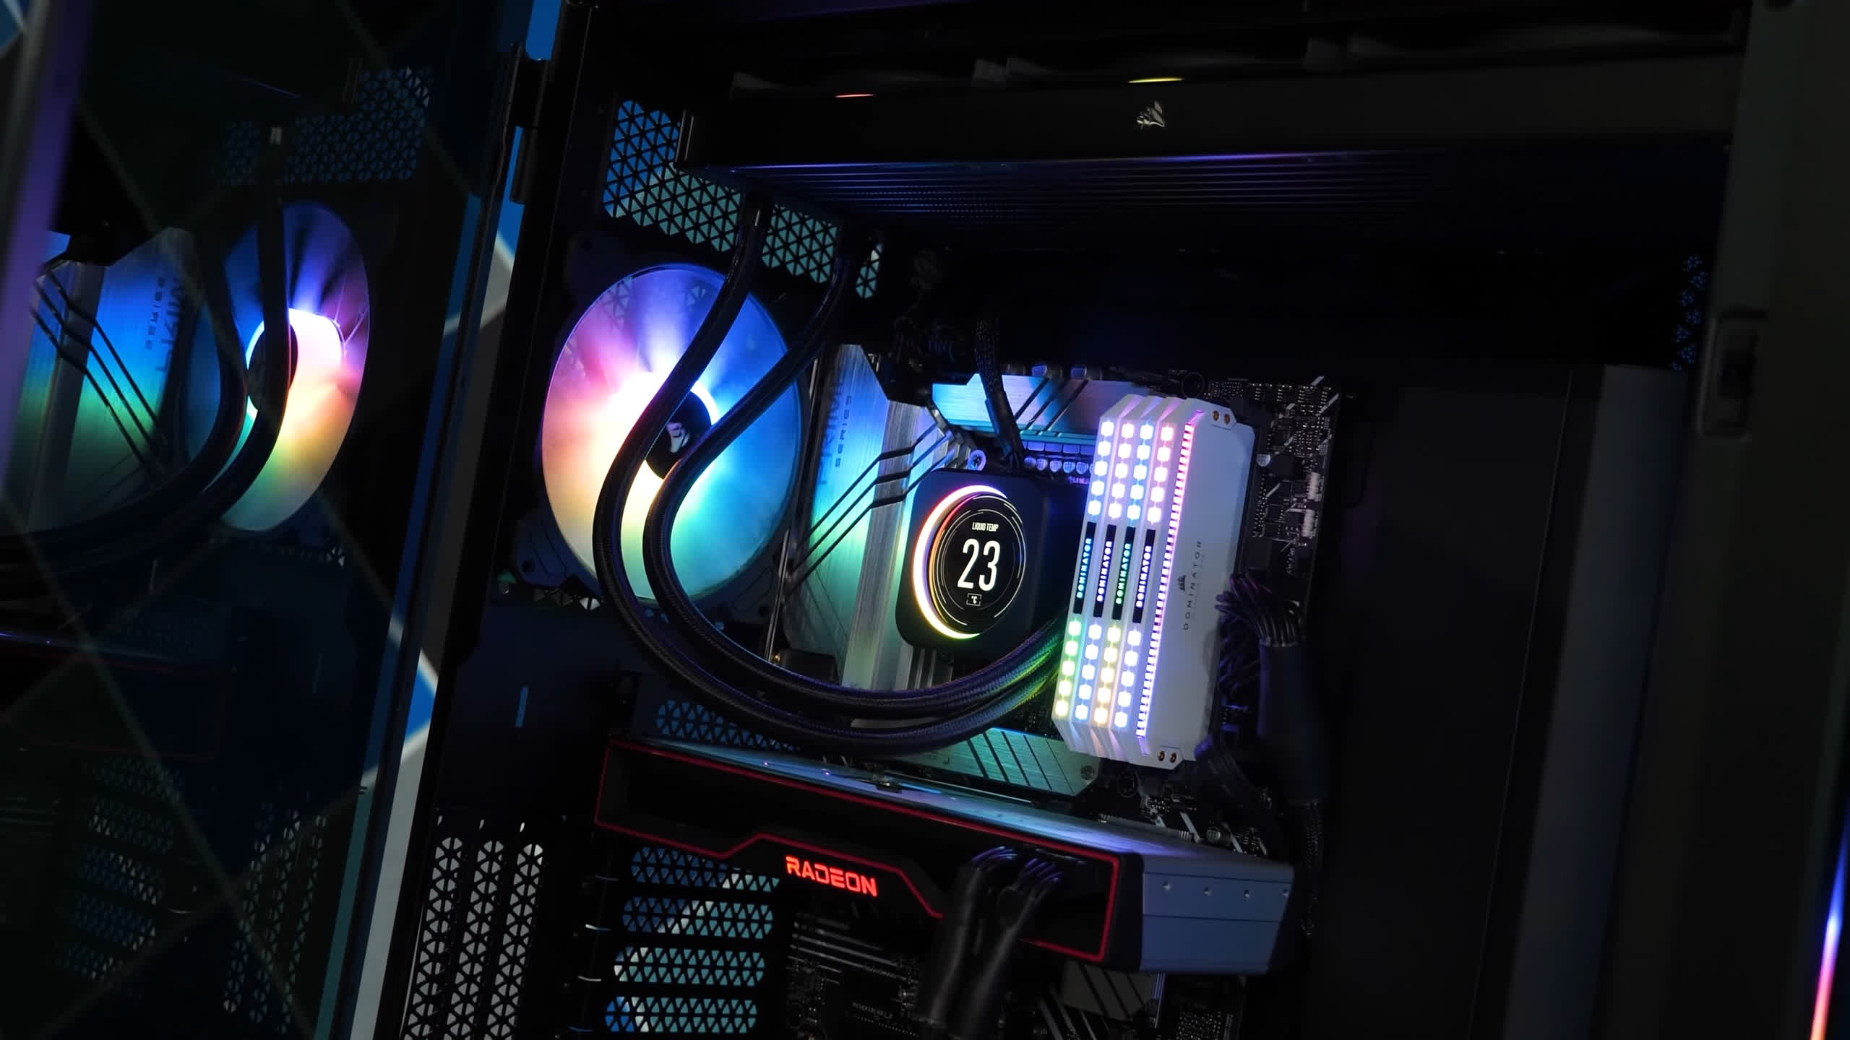

**Latency and Memory Bandwidth**

We'll start by looking at memory bandwidth with AIDA64's copy test. We're looking at a throughput of of 33.5 GB/s using the DDR4-2400 kit in its stock configuration, which defaults to gear 2 mode. Switching to gear 1 increases that number by 17%, but we're still limited to just under 40 GB/s.

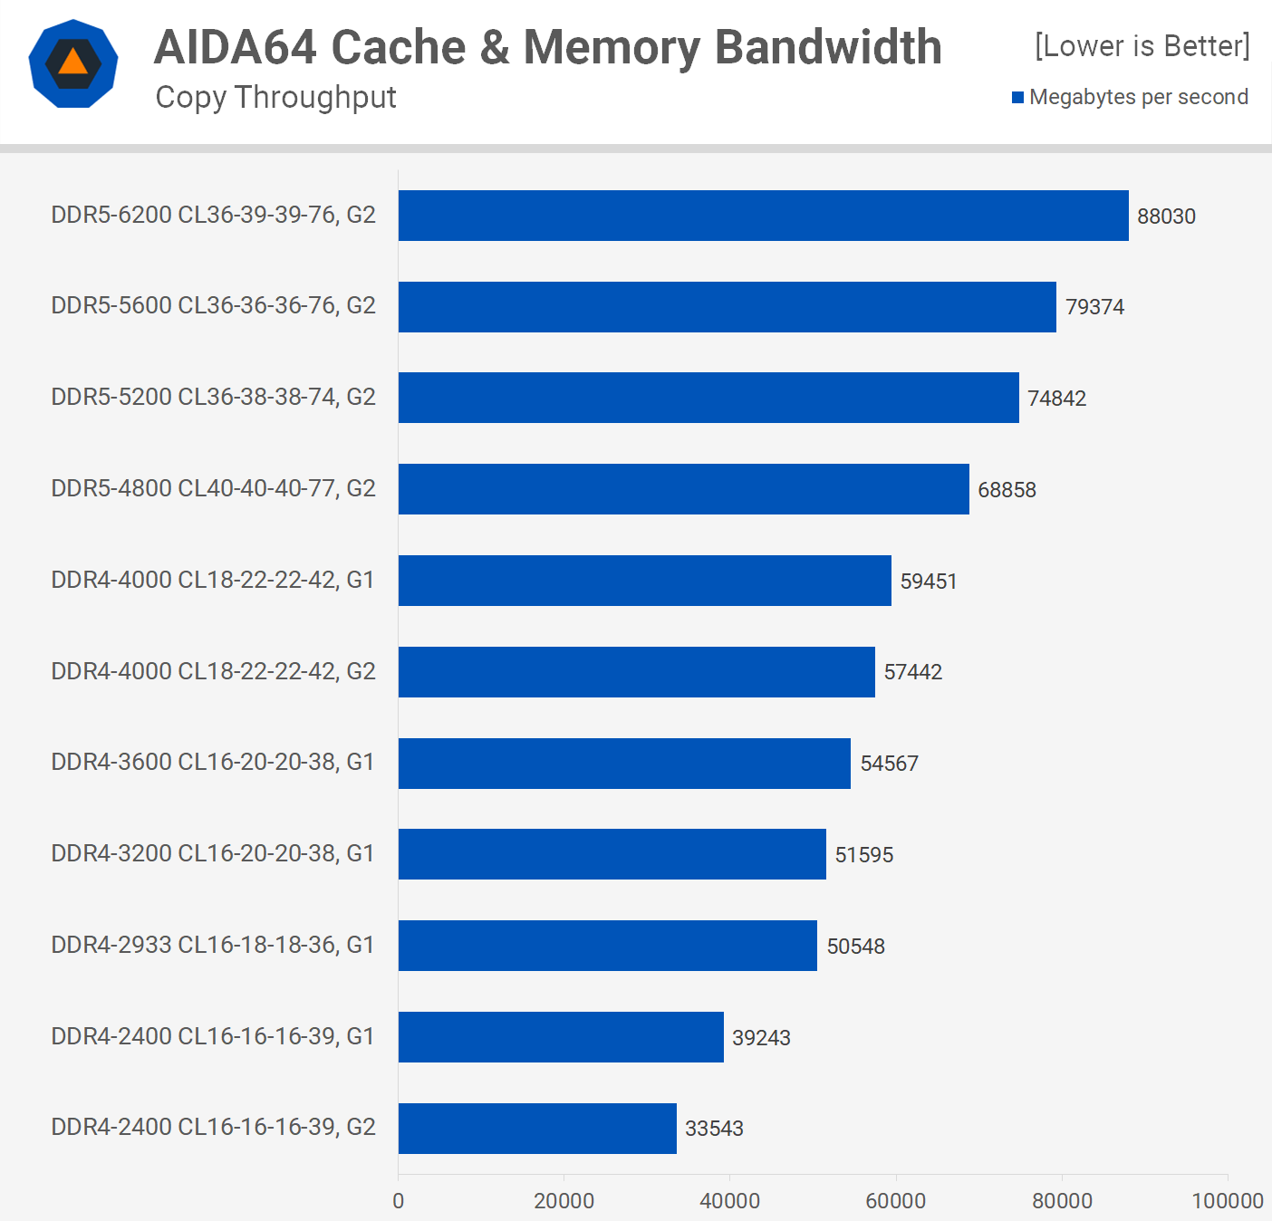

DDR4-2933 provides a bit of a performance boost, increasing bandwidth by about 30%, whereas DDR4-3200, which has slightly weaker timings, only improves bandwidth by 2%. Beyond this point, DDR4 offers only minor gains, with a 15% boost from 3200 to 4000 being the most significant. That's not insignificant, but with a 25% increase in frequency, it's not a significant rise that can be explained by greater timings.

We did have a faster DDR4 kit from Corsair, but it didn't function on our Z690 board, so we had to settle with DDR4-4000 at slightly under 60 GB/s. This means that, as is customary, CL16 DDR4-3600 to CL18 DDR4-3800 will be the most cost-effective option.

We saw a 16 percent boost in throughput from DDR4-4000 to DDR5-4800, and we're practically at 70 GB/s presently. Then there's a 9% rise from 4800 to 5200, a 6% boost from 5200 to 5600, and an 11% gain from 5200 to 6200, resulting in an amazing 88 GB/s transfer speed. However, memory bandwidth isn't everything, and memory latency is more significant for many workloads, so let's look at it.

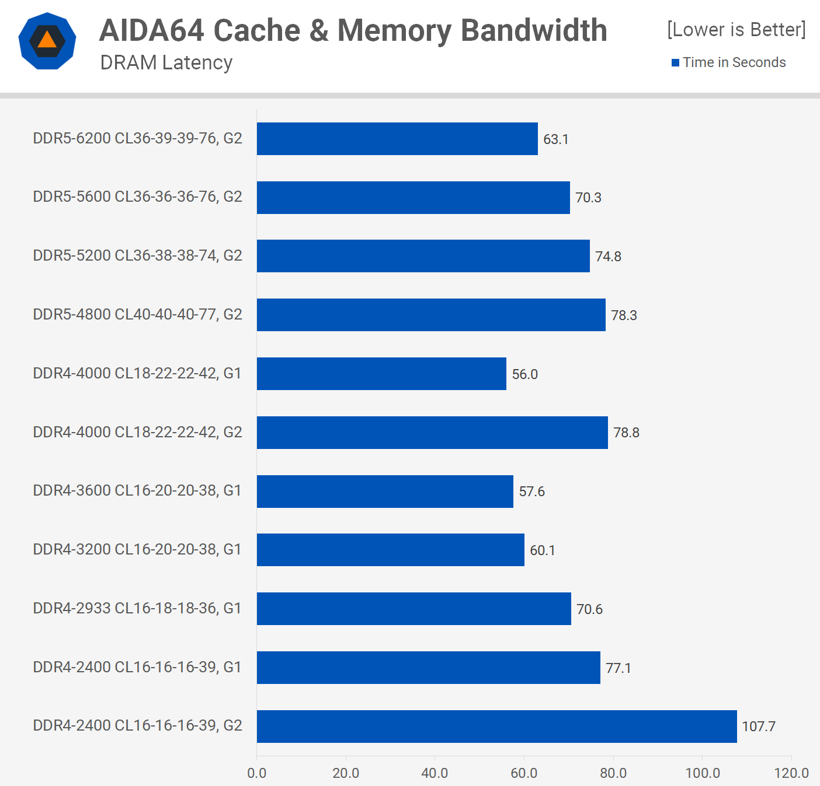

The AIDA64 DRAM latency data can be found here. The period between when a command is entered and when the data is available is referred to as DRAM latency. As a result, measuring latency in nanoseconds is the best approach to assess a memory module's responsiveness.

**Application Benchmarks**

Because the CAS delay or CL timings are only one component of the equation, you can't measure RAM's performance only on the CL timings, which is why DDR5 and its ostensibly high CL values have perplexed many people. Memory frequency (delay) and CL timings (latency) are both important factors in system performance.

Despite delivering much higher bandwidth, DDR5 has yet to achieve the frequencies or timings required to outperform most DDR4 modules in terms of latency.

There's also the DRAM ratio, which Intel currently refers to as gear 1, 2, and 4. The memory controller in gear 1 operates at the same frequency as the DRAM, however in gear 2, the memory controller operates at half the memory speed, resulting in significantly increased latency but allowing you to run memory at higher frequencies for increased bandwidth.

You should utilise gear 1 with DDR4 RAM because you'll need to operate it at DDR5 speeds to compensate for the additional latency. When upgrading from gear 1 to gear 2 with DDR4-2400, we're looking at a 40% increase in latency, which will cripple performance in memory-intensive tasks like gaming.

When it comes to DDR4 memory, we notice that the sweet spot is approximately 3600 MHz, with DDR4-4000 lowering latency by only a few milliseconds over the CL16 3600 kit.

Then, despite the significantly higher operating frequency, latency does not improve over DDR4, which is due to the Alder Lake memory controller's inability to run at a 1:1 ratio with the DRAM, forcing us to use gear 2 mode for all DDR5 testing. Even at 6200, the latency is still 63ns, which is higher than even DDR4-3200 CL16 memory. As a result, DDR5 will succeed in applications and games that require a lot of memory bandwidth but aren't as sensitive to latency for the time being.

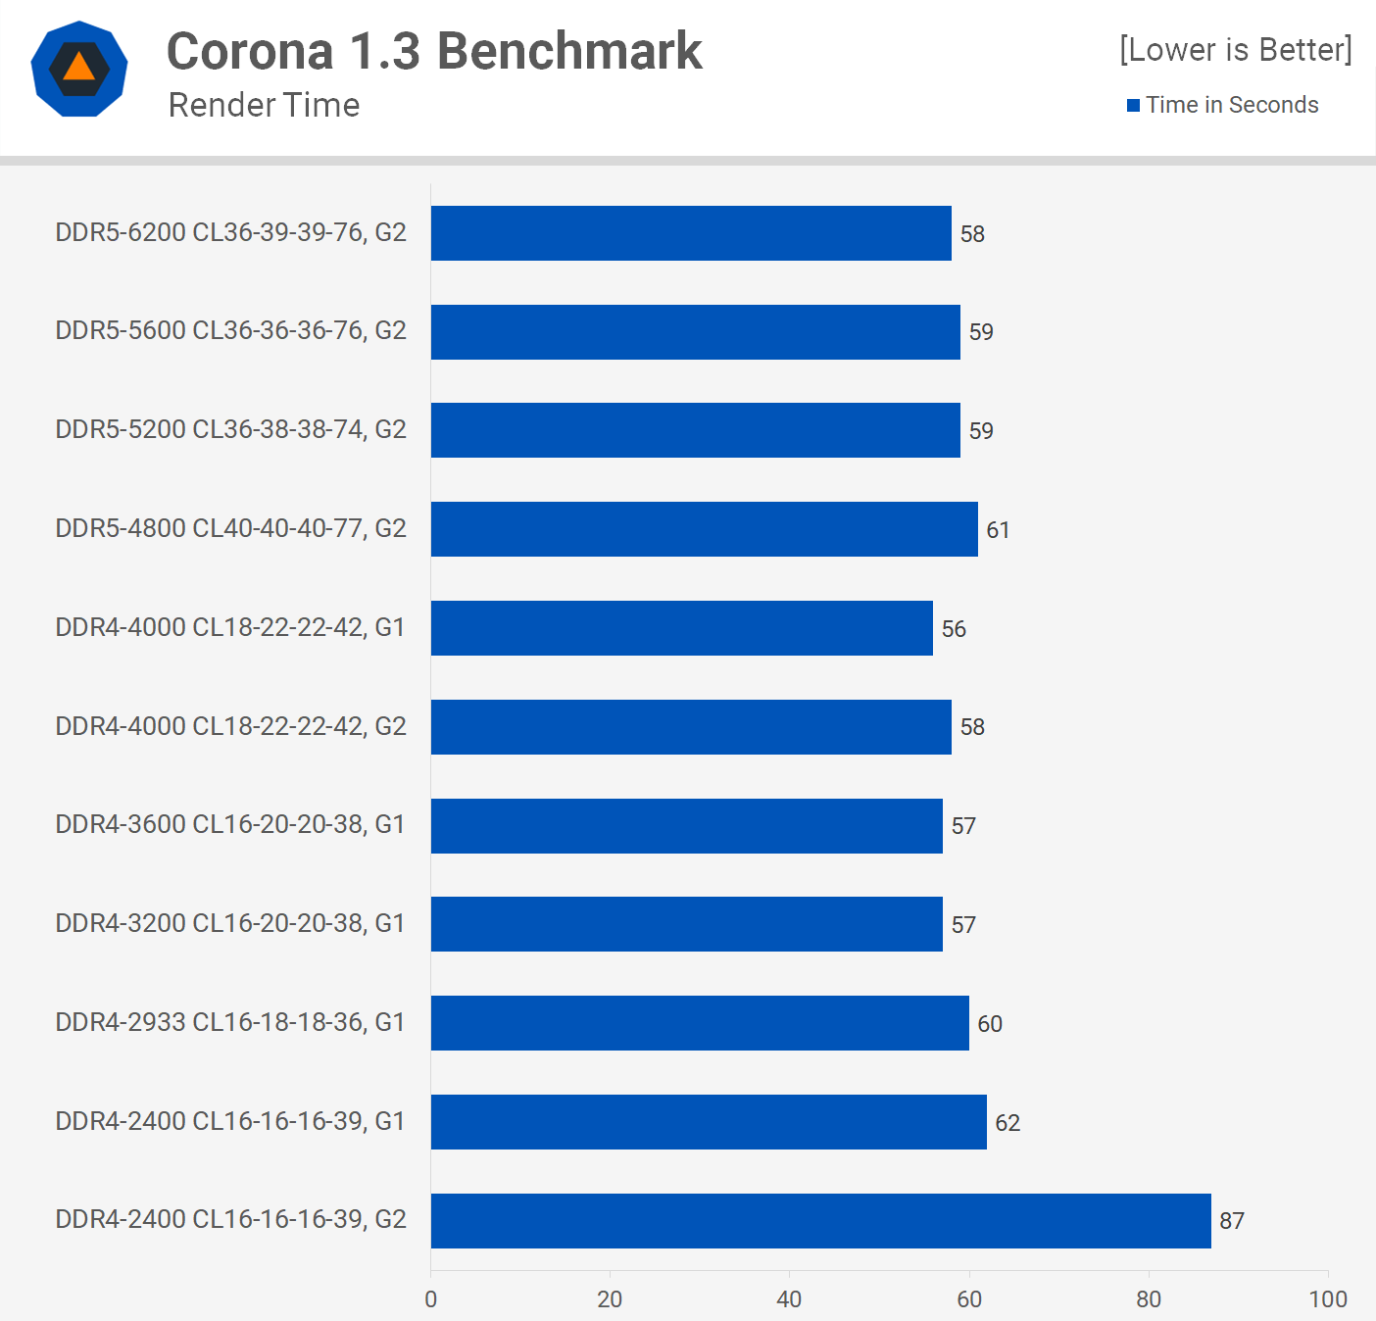

However, many applications, such as Corona, are memory latency and bandwidth sensitive. So if your memory bandwidth is poor and your latency is poor, your overall performance will suffer, as we can see with the DDR4-2400 kit in gear 2 mode, which was the default for this configuration.

The majority of the memory kits, on the other hand, offer either strong bandwidth performance or decent latency, thus the gap between the fastest and slowest kits is only about 11%. The best results were achieved with DDR4-4000 CL18 using gear 1, however DDR4-3200 and 3600 CL16 also outperformed all DDR5 kits.

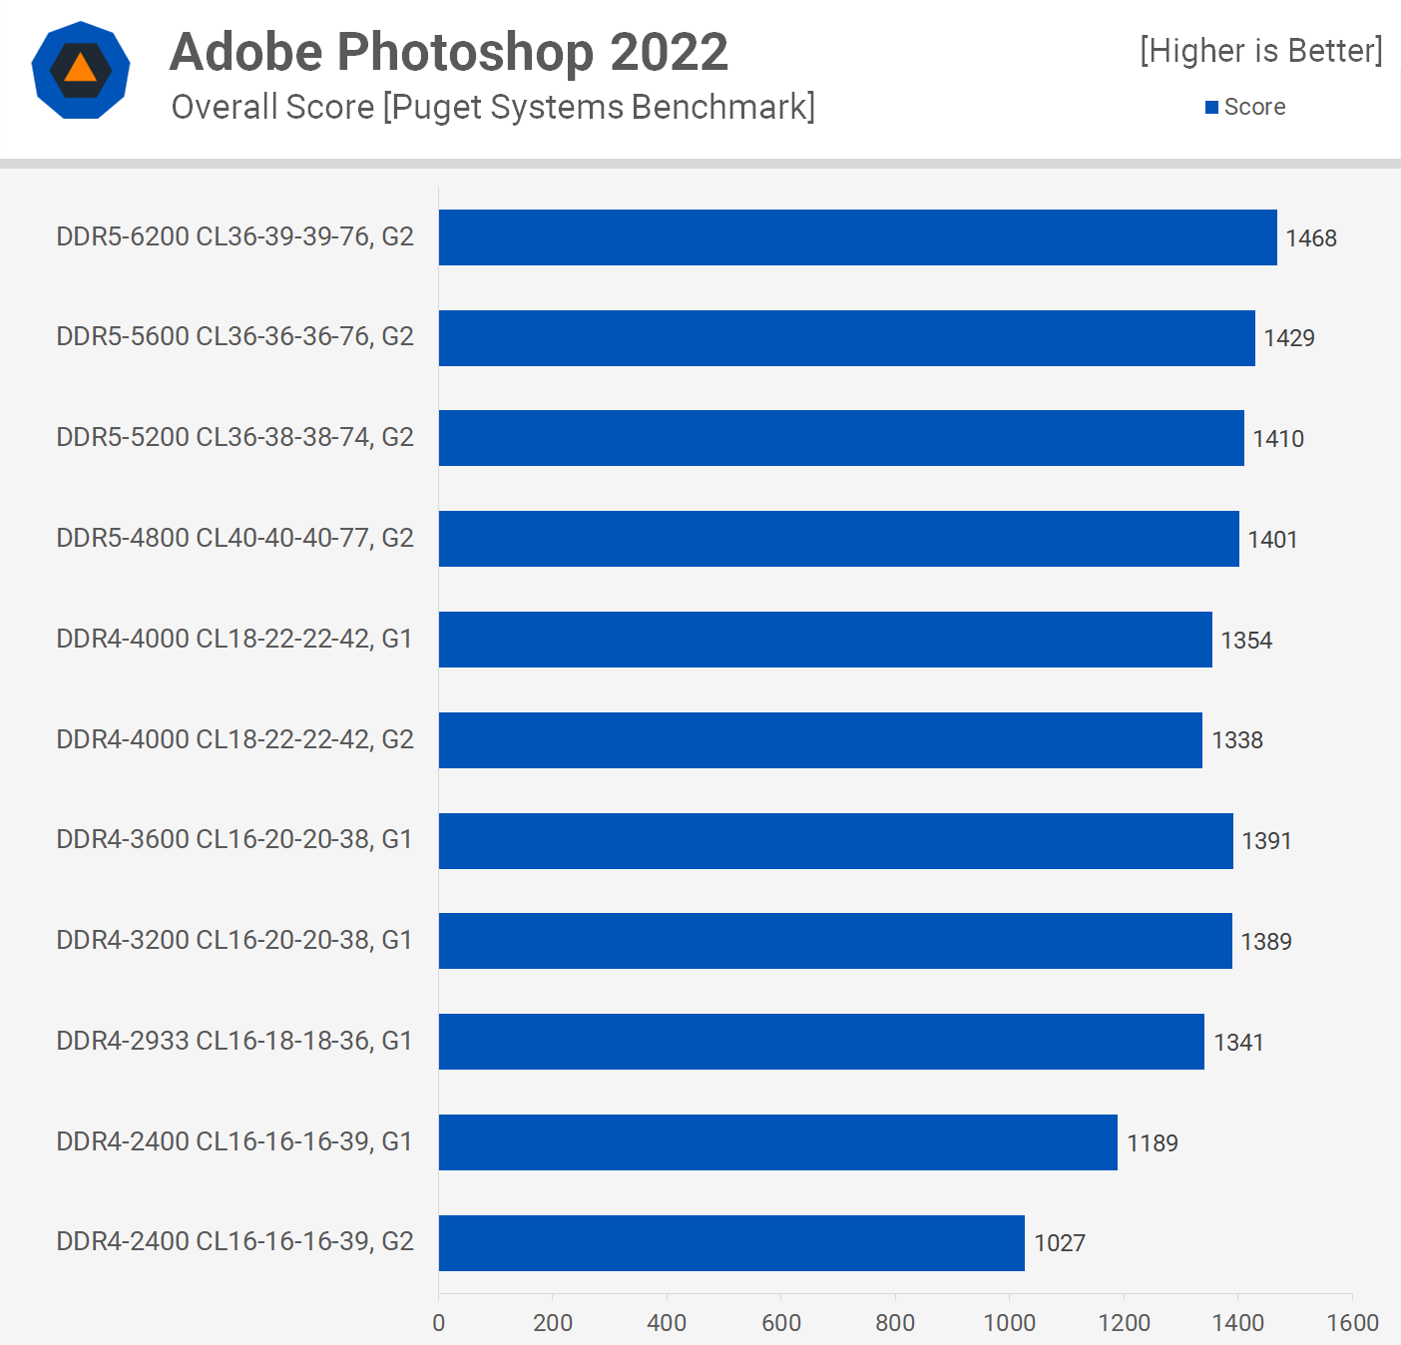

Adobe Photoshop is unusual in that it is more sensitive to memory bandwidth, which advantages DDR5 memory, which delivered the greatest results. DDR4-3600 and 3200 CL16 were not significantly slower than most DDR5 kits, but if you're looking for optimal performance in this application, DDR5 memory is the way to go.

**Gaming Benchmarks**

It's time to play some games, and we'll start with Rainbow Six Siege using the Radeon RX 6900 XT with the ultra quality preset at 1080p. The 12900K can drive above 500 fps in gear 2 mode using DDR4-2400 memory, which implies the best DDR4 results, which were seen with DDR4-3200 memory, were only 9% quicker when comparing the average frame rate, or 14 percent faster for the 1% lows.

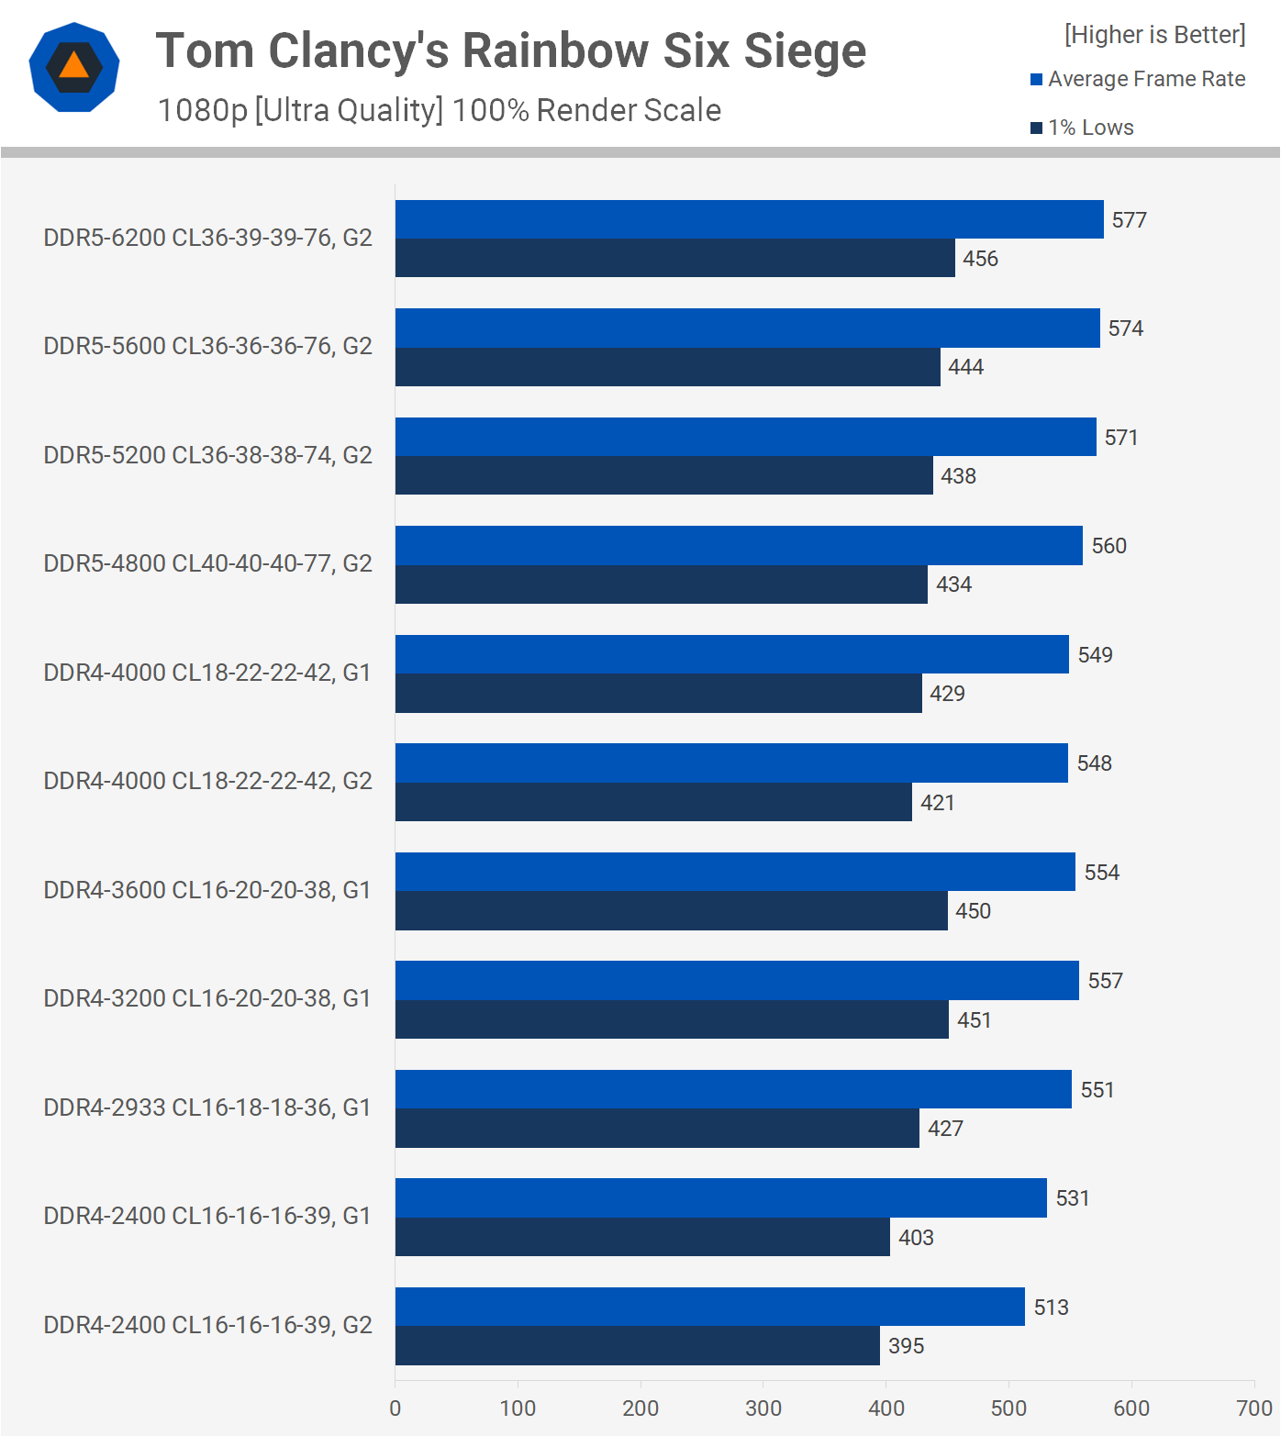

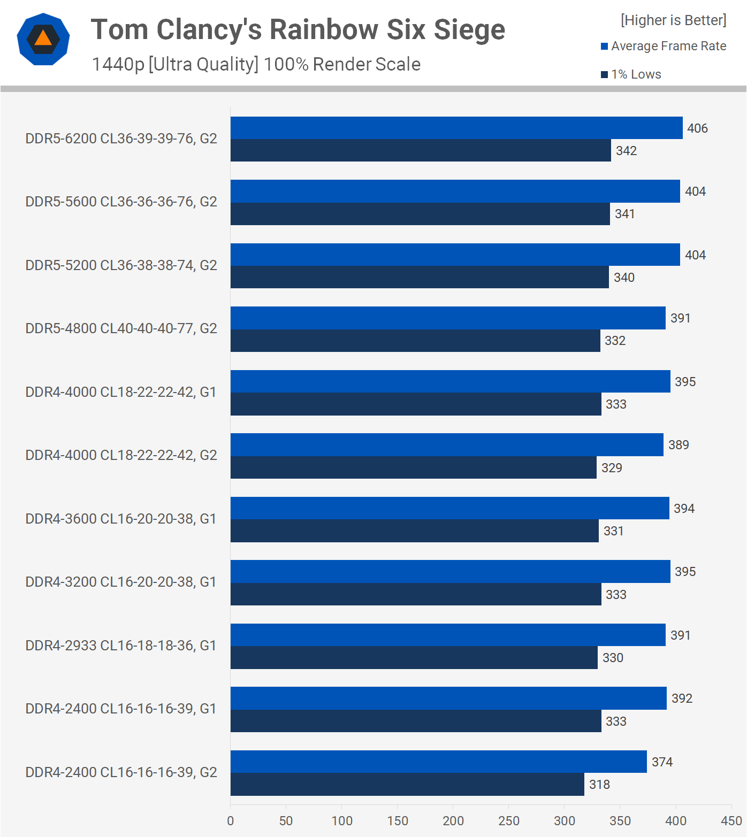

Although the DDR4-4000 memory provided a similar average frame rate, the higher latency did minimise the 1% lows. DDR5, on the other hand, was able to keep up with the average frame rate, but it had to operate at 6200 speeds to beat the 1 percent lows of the high-quality DDR4 memory.

Things change quite a deal as we increase the resolution to 1440p, however the margins are now lower as we become GPU limited. Even though DDR5-6200 is only 3% faster than DDR4-3200, DDR5-5200 and higher currently give the greatest 1% low performance and the highest average frame rates.

Horizon Zero Dawn has been evaluated with the "Favor" quality preset, and we'll start with the 1080p data once more. We look to be GPU constrained for the most part, and this will remain the case for 12900K owners in the great majority of games, even with an extreme GPU.

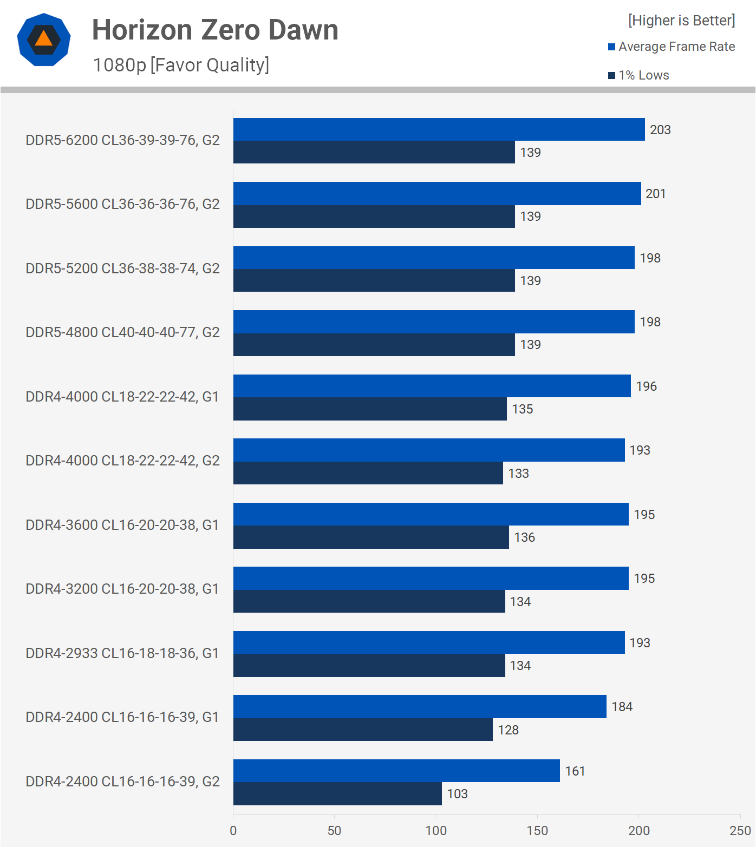

When we go to DDR4-2933 CL16, we'll be near to maxing out what we can do here. The higher-clocked DDR5 memory provides a slight performance advantage over DDR4-3600, although it's just about 4%.

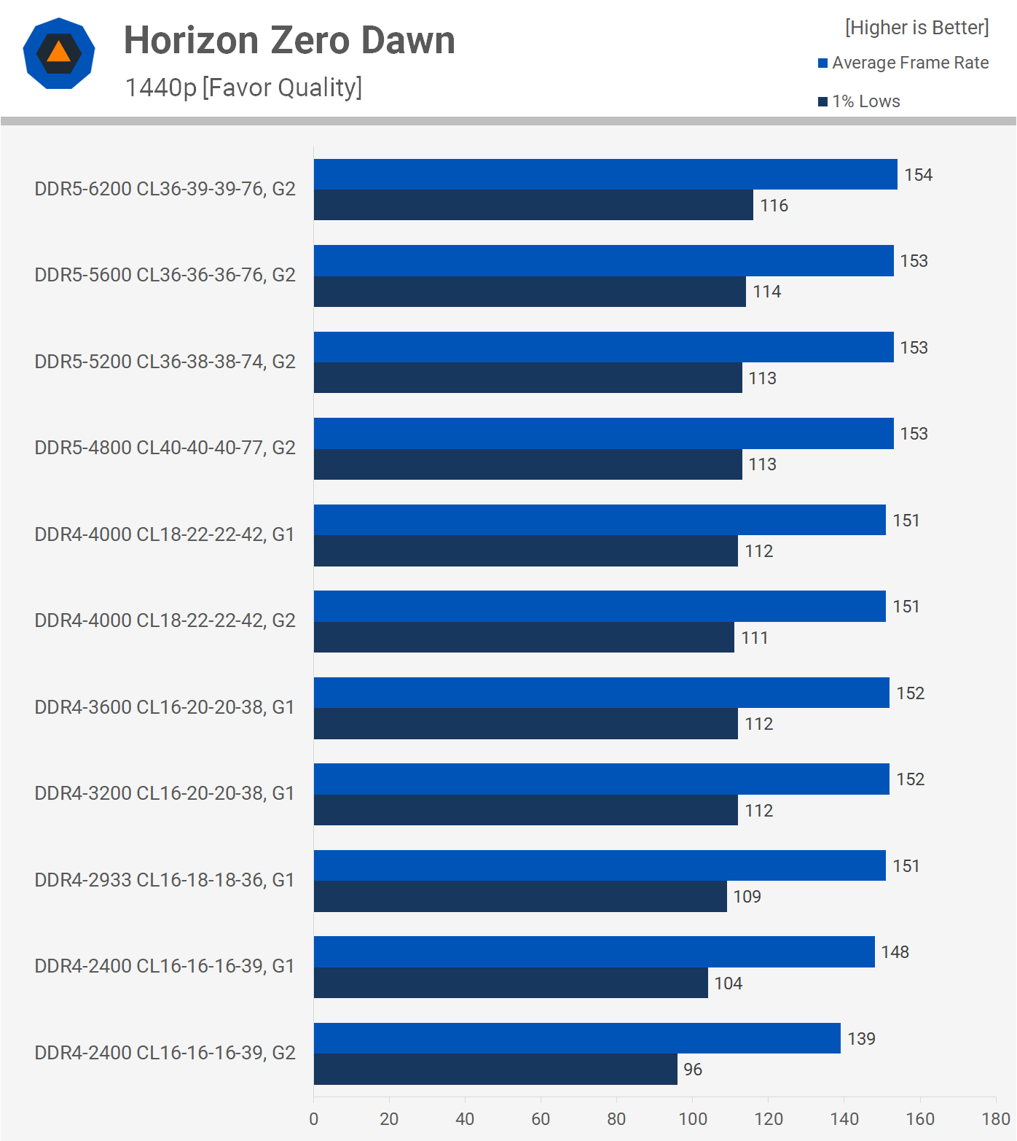

Moving to 1440p decreases the already slim margins even more, and anything above DDR4-3200 now provides essentially the same level of performance.

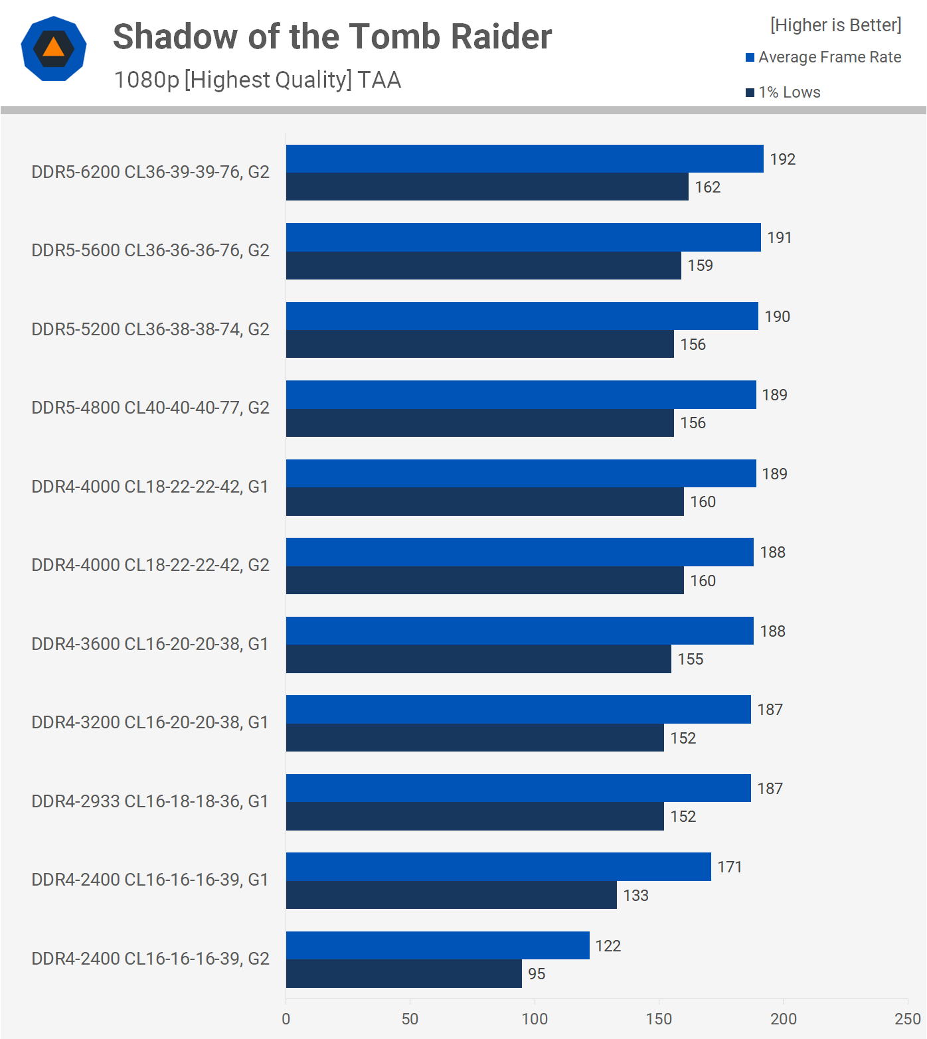

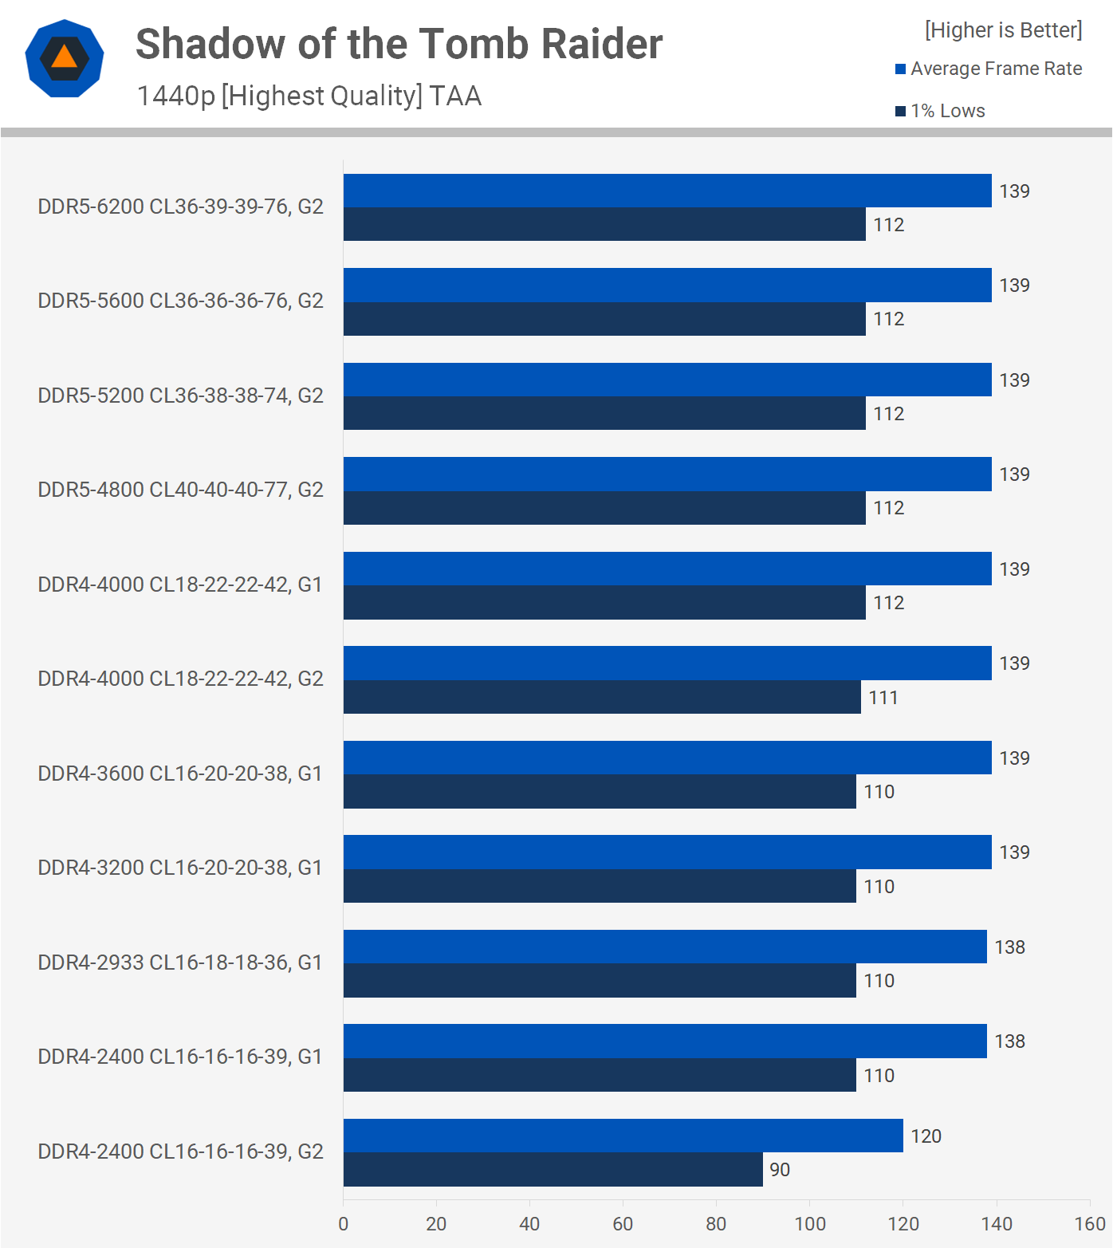

Shadow of the Tomb Raider is a CPU-intensive game, however by the time DDR4-2933 CL16 is reached at 1080p with a 6900 XT, we've been able to switch the game from CPU to GPU limited. We do notice tiny increases when memory performance improves, but from 2933 to 6200, we're only talking about a 7% boost in 1% lows.

With the exception of the gear 2 mode for the DDR4-2400 memory, which reduced the average frame rate by 13%, switching to 1440p neutralises the test findings.

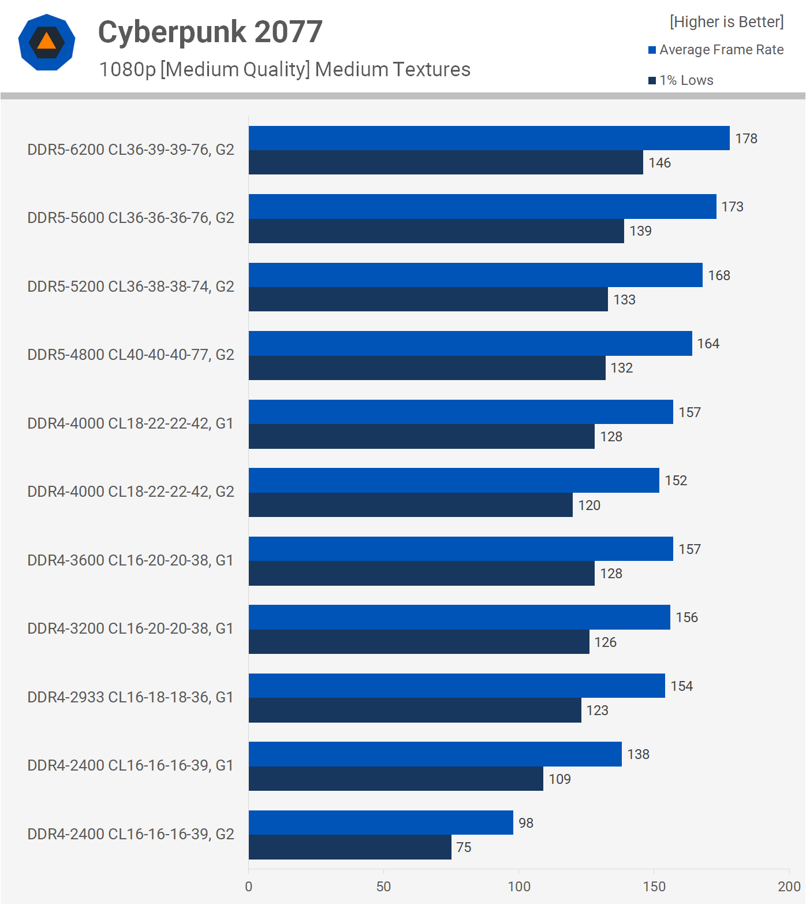

The medium quality preset was used to test Cyberpunk 2077, and at 1080p, there is a significant performance disparity between the various RAM setups. Switching to gear 1 increased the average frame rate by 41%, indicating that the DDR4-2400 gear two setup entirely stifles performance.

Then, from 2400 to 2933, we see another 12% boost, and DDR4 is maxed out at that point, with 3200, 3600, and even 4000 just providing a few extra frames.

DDR5 improves performance slightly; DDR5-4800 was 4 percent faster than DDR4-4000 and 3600, and we saw a 3-4 percent boost with each level up to DDR5-6200, averaging 178 frames per second. DDR5-6200 was thus 13 percent faster than DDR4-4000 in the end.

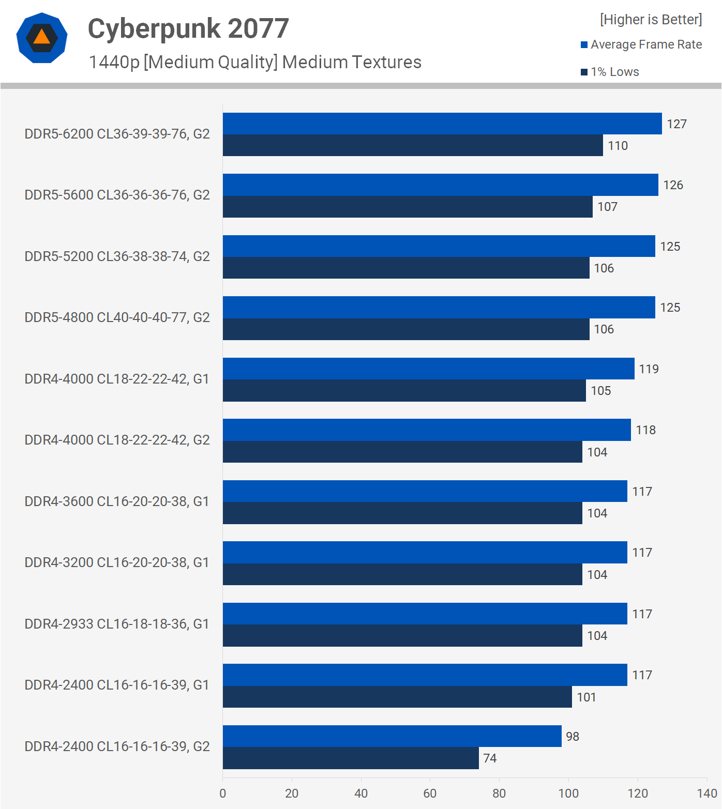

The higher bandwidth of DDR5 helps to boost performance, as switching from DDR4-4000 to DDR5-4800 raised the average frame rate by 5% while having little effect on 1% lows.

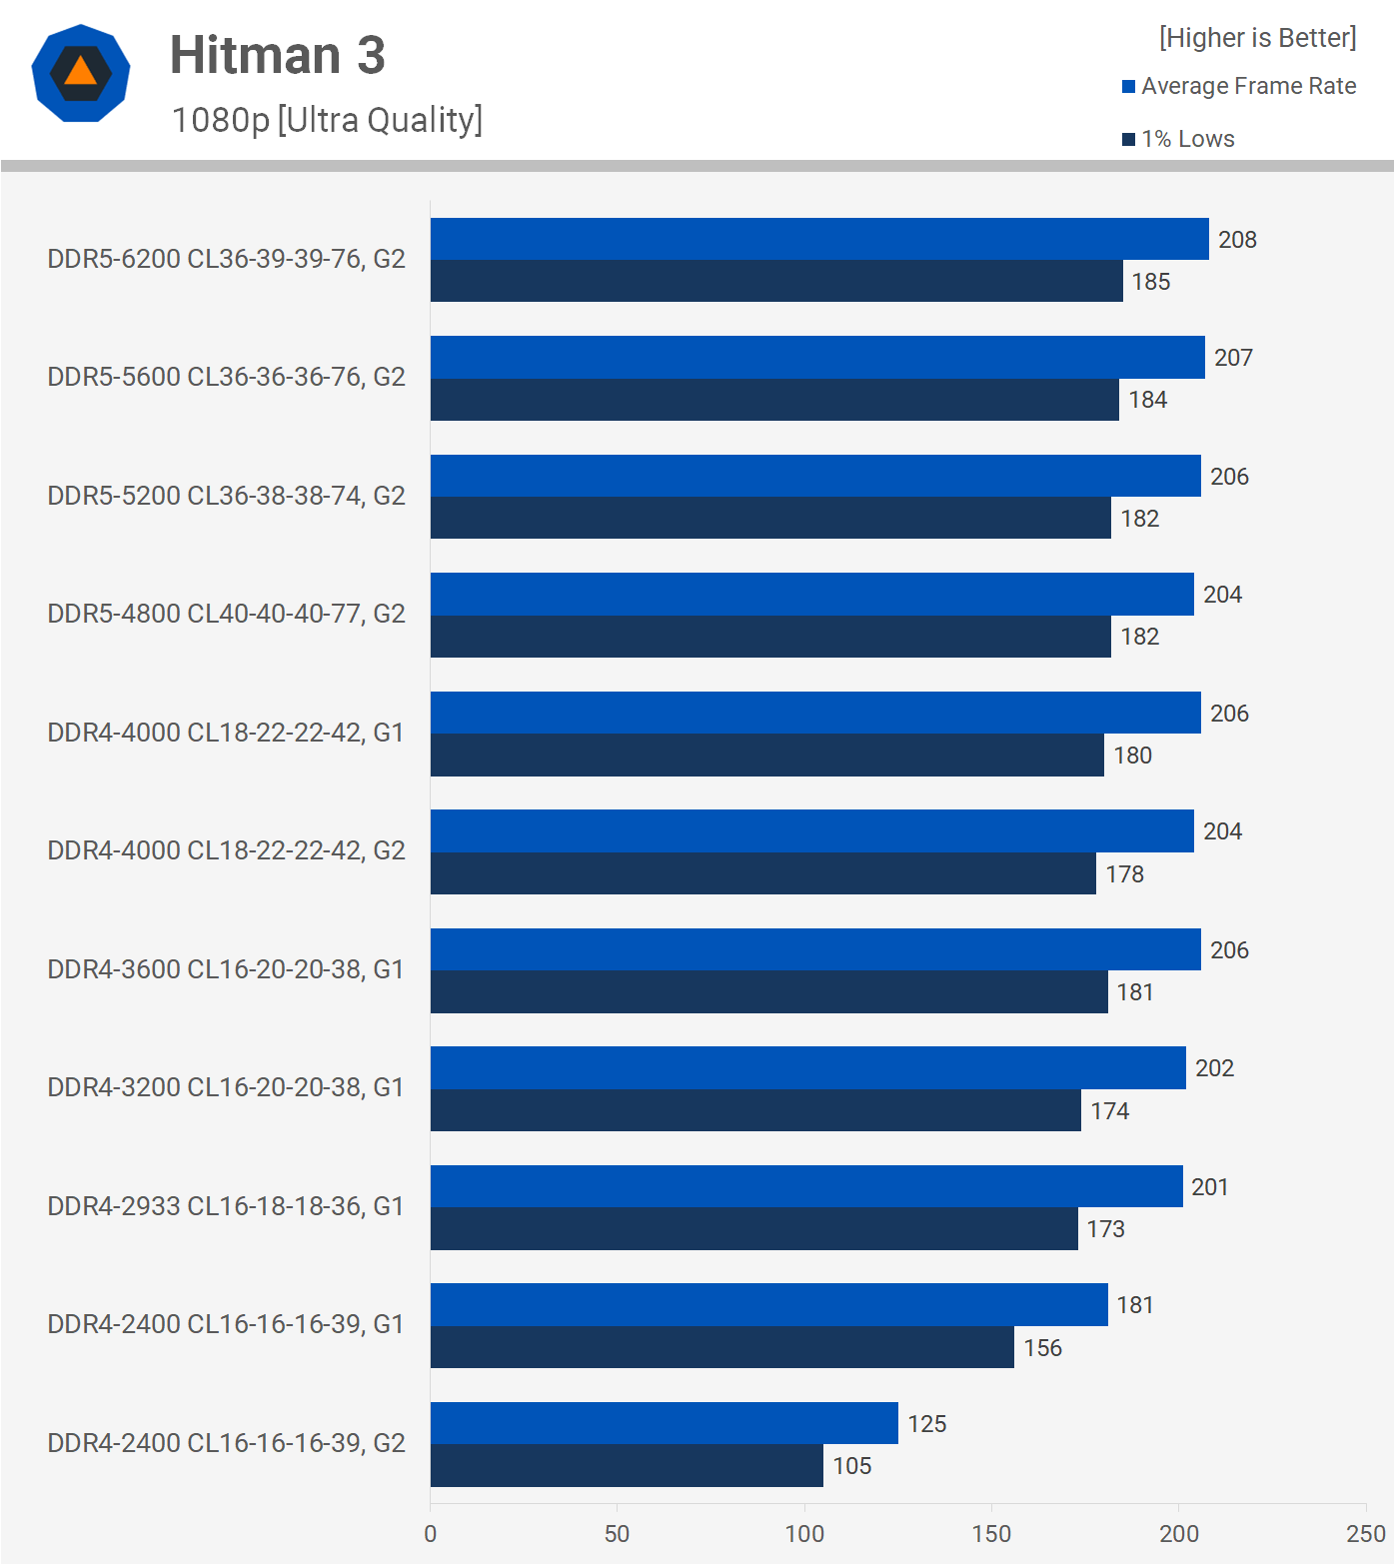

Finally, we have Hitman 3, where the DDR4-2400 gear 2 setup is the only one that noticeably slows down at 1080p. Switching to gear 1 raised frame rates by 16 percent, while DDR4 reached its pinnacle with the 3600 kit, which was just 5% faster than the 2400 with gear 1.

Even with the 4800 spec kit, DDR5 didn't do much to enhance 1 percent lows, but it did increase the average frame rate by 5%.

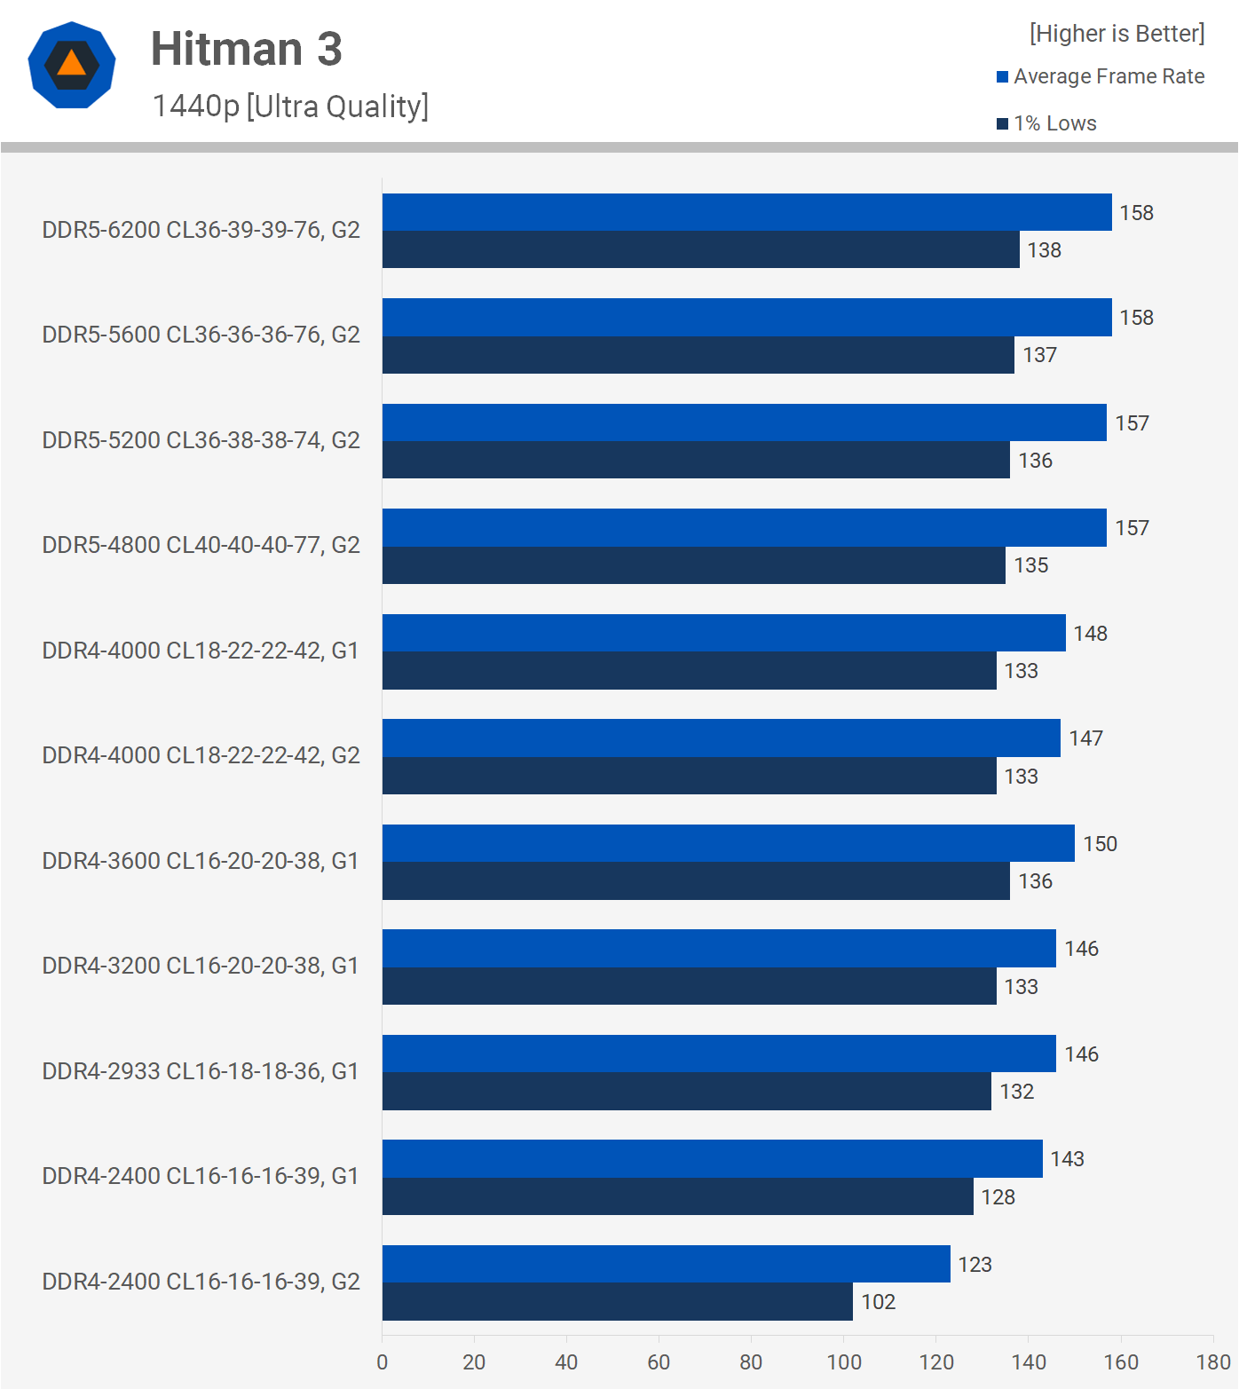

The Core i9-12900K was pretty well maxed out utilising DDR4-2933 when we increased the resolution to 1440p, where we're still hitting over 200 fps for the most part. Of course, from DDR4-2933 to DDR5-6200, we notice a 7% rise in 1% lows, but that's a minor change given the enormous boost in bandwidth DDR5 provides.

**Which Alder Lake DDR4/DDR5 Memory Kit?**

That's a comprehensive look at Alder Lake performance with the Core i9-12900K with a variety of DDR4 and DDR5 memory packages. Now it's up to you to decide what to buy. Looking at pricing first is the greatest method to answer that issue...

Although we tested DDR4-2400 and 2933 memory, we should probably exclude those kits because they are usually more expensive than DDR4-3200, and in some cases 3600. The Corsair Vengeance LPX memory we used costs $115 and starts at $100 for a 32GB DDR4-3200 CL16 kit.

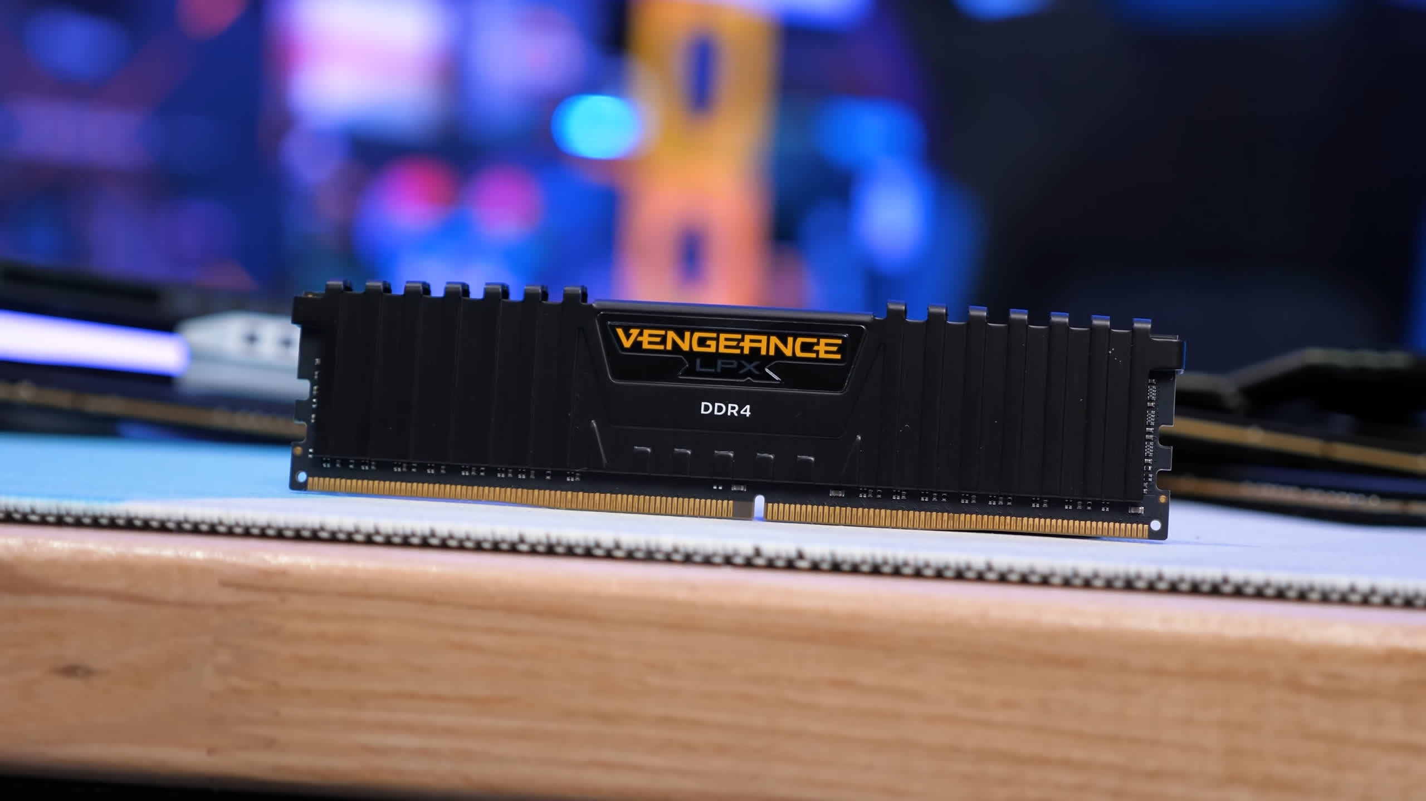

The LPX kit for DDR4-3600 costs $140, with the Vengeance RGB RT we tested costing $150, however similar spec memory starts at roughly $120. Then there's DDR4-4000, which wasn't much faster than the 3600 kit for the most part, but starts at $200 from Corsair. Similar spec kits, like as the G.Skill Ripjaws V Series, can be found for as little as $135, and that memory is extremely difficult to beat at that price.

Depending on your region's pricing, the sweet spot for DDR4 memory is between 3600 and 4000. While the Core i9-12900K is CPU limited, DDR4-3200 CL16 and higher will perform admirably and get the most out of the processor, thus keep that in mind when making your purchase.

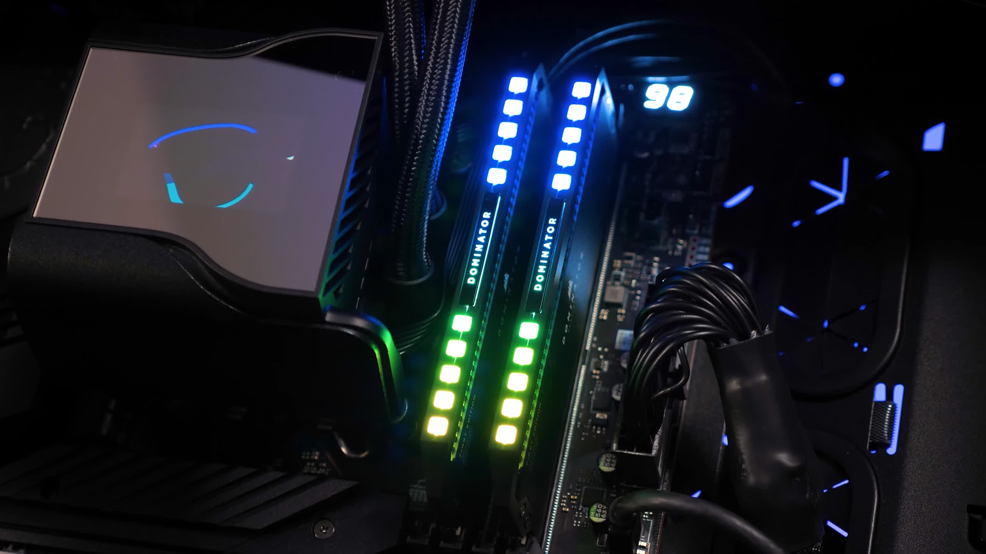

DDR4 memory is what you'll want if you want to get the most out of an Alder Lake processor, and there's no reason to go higher than DDR4-4000, as far as we can tell. So, if DDR4-3200 CL16 and DDR4-4000 CL18 are both reasonably priced in your area, you might as well go with 4000.

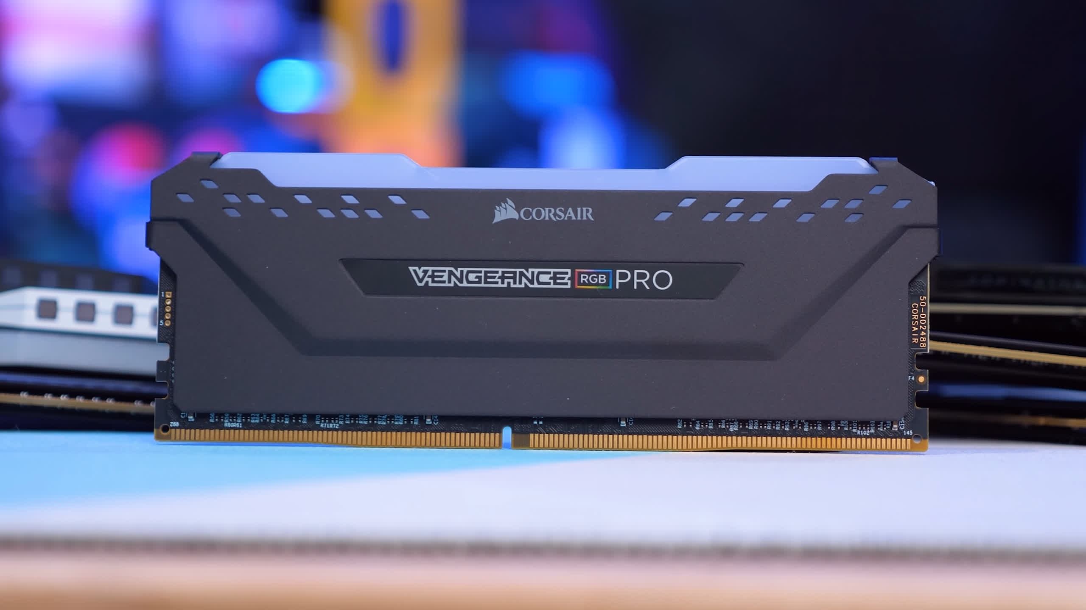

When it comes to DDR5, there's little point investing in it right now unless you're looking for the best of the best, in which case you'll want 6000+ spec memory, which costs nearly the same as the 12900K processor. If you're gaming, there's little reason to go with the less expensive 4800 to 5600 memory, especially because you'll almost certainly be GPU limited.

You might be able to justify the cost of high-end DDR5 for productivity jobs where time is money, but you'll also want to be sure the 12900K is the fastest processor for that workload; otherwise, the Ryzen 9 5950X or a Threadripper CPU might be a wiser investment.